Open Source Wireless Sensor System for Indoor Air Quality Monitoring

ECE 412 / 413

Sponsor: Dr [David Burnett](mailto:dburnett@pdx.edu)

Advisor: Dr John Acken

Team: Adam Dezay, Manuel Garcia, Brandon Hippe, Mercedes Newton

# **Table of Contents**

**Table of Contents** **1**

**1. Executive Summary** **2**

**2. Background** **2**

**3. Project Overview** **2**

**4. Product Design Specification** **3**

4.1 Concept of Operation / User stories 3

4.2 Stakeholders 3

4.3 Requirements 4

4.4 Deliverables 5

4.5 Initial Product Design 5

4.6 Verification plans 8

**5. Project Management Plan** **9**

5.1 Timeline, with milestones 9

5.2 Budget and Resources 10

5.3 Intellectual Property Discussion 10

5.4 Team and development process 11

**6. Appendices** **12**

6.1 Configurations sorted by lowest power consumption / sampling rate 12

6.2 CO2 Sensor Comparisons 16

6.3 PM2.5 Sensor Comparisons 17

6.4 Airflow Sensor Comparisons 19

**Proposal Outline and Discussion**

## **1. Executive Summary**

Air quality is very important for safe working conditions. There should be a monitoring system for environmental risks and air pollutants such as CO2 and fine particulate matter (PM2.5), as well as ventilation rates. This can be similar to smoke detectors. This team’s goal is to build a device to monitor elevated or dangerous quantities of these pollutants using as many commercial off-shelf components as possible. The aim is to create 3 to 10 wireless, battery powered initial prototypes that have at least one year life span.

## **2. Background**

The team wants to make it easy to continuously monitor an indoor environment, and report data back to a host. The aim is to make it easy by making cheap, reliable devices that don't need recharging for a long time. Three features of indoor air are expected to be monitored: 2.5 μm particle count or PM2.5, carbon dioxide (CO2) concentration, and ventilation air speed.

Regarding CO2, statistically significant decrements occurred in cognitive performance

(decision making, problem resolution) starting at 1000 ppm[1]. It is also a

good proxy for ventilation; high CO2 levels mean the room is poorly ventilated, which increases

the risk of passing airborne diseases such as COVID.

Regarding PM2.5, the WHO recommends an upper limit of 5 µg/m3 [2](microgram per cubic

meter) average annually and 15 µg/m3 average over a 24 hour period .

An air speed sensor, or anemometer, can help us calculate how much air is flowing into or out of

a room and help understand why CO2 and/or PM2.5 is high.

The system will be based on components past capstone teams have successfully incorporated

such as the TI MSP430 (including super low-power sleep modes). In this iteration, a goal is to

replace the closed-source proprietary SmartMesh IP wireless system with the OpenWSN open-source wireless networking system.

This project is sponsored by the Wireless Environmental Sensor Technologies (WEST) Lab in the Electrical and Computer Engineering Department at Portland State, run by Dr. David Burnett. The project’s faculty advisor is Dr. John Acken.

## **3. Project Overview**

From project description document:

Produce a fully wireless sensor data logger incorporating as many open-source components as

possible and able to be produced at a very low cost. A particular goal of this project is very low

power performance: sensors, communication system, and the microcontroller should be in as

low a power state as much as possible when not in use such that batteries need to be changed, at most, annually. (The lifetime of a smoke detector would be even better!)

Data should be temporarily logged locally and wirelessly communicated to base station(s) as appropriate. A stretch goal includes a visualization dashboard to present the logged data graphically for at-a-glance use. The device should be mechanically integrated into as small a

form-factor as is practical and contained in a robust housing appropriate for indoor

Environments.

The team anticipates the project consisting of two phases:

Phase 1: Select, implement, and assess performance of sensors. In particular this includes

energy consumption characterization, and investigation of whether sensors can be put into deep

sleep mode between use. If their deep sleep mode is deemed not low-power enough, the team will investigate whether they are tolerant to total power disconnect (via, e.g., MOSFET switches)

when not in use. In other words, does it save enough energy to totally disconnect the sensors?

Phase 2: Make it wireless. Incorporate sensor implementations into a complete system that

periodically wakes up, takes measurements, transmits them wirelessly, and goes back to sleep.

This phase will include overall system energy profiling to determine how much battery power will

be required for at least 1 year of operation.

## **4. Product Design Specification**

### **4.1 Concept of Operation / User stories**

For use, the user should be able to place many sensor systems throughout the environment they want to monitor. The systems should be able to automatically sense their surroundings and communicate their measurements between sensor systems and a central monitoring/data collection system. The sensor systems should be able to be set up and forgotten, requiring little maintenance such as battery charging, for ideally around a year.

### **4.2 Stakeholders**

Industry Sponsor : Dr. David Burnett (Principal Investigator of WEST Lab at Portland State University)

Faculty Advisor: Dr. John Acken

Engineers:

* Adam Dezay
* Manuel Garcia
* Brandon Hippe
* Mercedes Newton

Customer: Any business in need of monitoring changing air quality conditions and their employees.

### **4.3 Requirements**

The sensor system must:

* Sense PM2.5, CO2 often enough and accurately enough to ascertain indoor air quality relevant to occupants
* Include at least one node capable of sensing airspeed
* Maximize its battery life for sustained operation
* Locally store its measurement data
* Use as many commercial off-shelf components as possible
* Have an enclosure
* Wirelessly share its measurement data with a central monitoring system with communication range of at least 10 meters
* Utilize SmartMesh IP
* Have 3 iterations that cost no more than $1,000 total

The sensor system should:

* Include capability for any node to sense airspeed
* Have a battery life of at least 1 year
* Be open-source to the extent possible when using commercial off-the-shelf components
* Upgrade SmartMesh IP to Utilize a low-power Wireless Sensor Network (WSN) system like OpenWSN
* Utilize Texas Instruments MSP430/432 class microcontroller unit
* Have 10 iterations that cost no more than $3,000 total
* Utilize 18560 lithium ion battery cell/s

The sensor system may:

* Incorporate a single 18650 battery
* Monitor other environmental conditions such as temperature and humidity
* Include self-configuration capability to detect which sensors are connected and adjust sampling rates accordingly
* Be usable outdoors
* Include a visualization dashboard to monitor the data graphically
* Be able to incorporate many more (>10) sensor modules
* Match lifetime of a fire detector (~10 years)

### 

### **4.4 Deliverables**

* Complete documentation
  + Project proposal
  + Weekly Progress Reports
  + Final report
  + ECE Capstone Poster Session poster
* Summary project report in the style of an IEEE conference paper as linked to in the "Manuscript Template" section of this page: https://ieee-sensors.org/sensors-letters/
* Bill of materials
* System schematic & functional diagram
* Design files for any custom mechanical components or PCBs
* Source code
* Operation guide
* Demonstration hardware
* Three to ten sensor system prototypes

These deliverables will be shared via Canvas assignment portal if available, otherwise it will be shared with Sponsor and Advisor via email. A combination Google Drive folder and Github repository will also be maintained to have all of the aforementioned documentation.

### **4.5 Initial Product Design**

There are a few other open source air quality monitoring systems that already exist, such as EnviroMonitor[3] and AirGradient[4]. Our system will be unique in that it is intended to be used as a network of sensor nodes each operating with long battery life.

Our design takes inspiration from smoke detectors. The goal is that each sensor node will be a small, self-contained unit that can be placed somewhere, set up, and then essentially forgotten. The team will design a custom PCB to handle connections between the MCU, sensors, and battery components inside of the node, and all the components will be housed in a custom designed 3d printable enclosure.

The hardware components will include:

* Texas Instruments MSP430/432 class microcontroller unit (MCU)
* 2.5 μm fine particulate matter (PM2.5) sensor
* CO2 sensor (Or equivalent CO2 sensor)
* Optional anemometer
* Custom PCB
* 18650 Lithium Ion Battery Cell(s)

Code for the nodes will be developed using Energia IDE/Code Composer Studio. For the host system, code will be based on the work of the 2022 Capstone team, who developed their host software in Python.

The L1 Block Diagram for the nodes and for the sensor network are as follows:

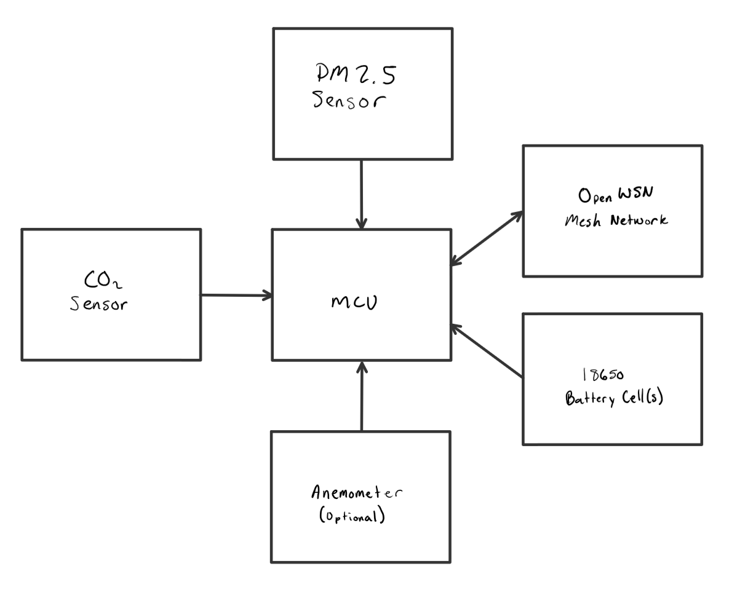

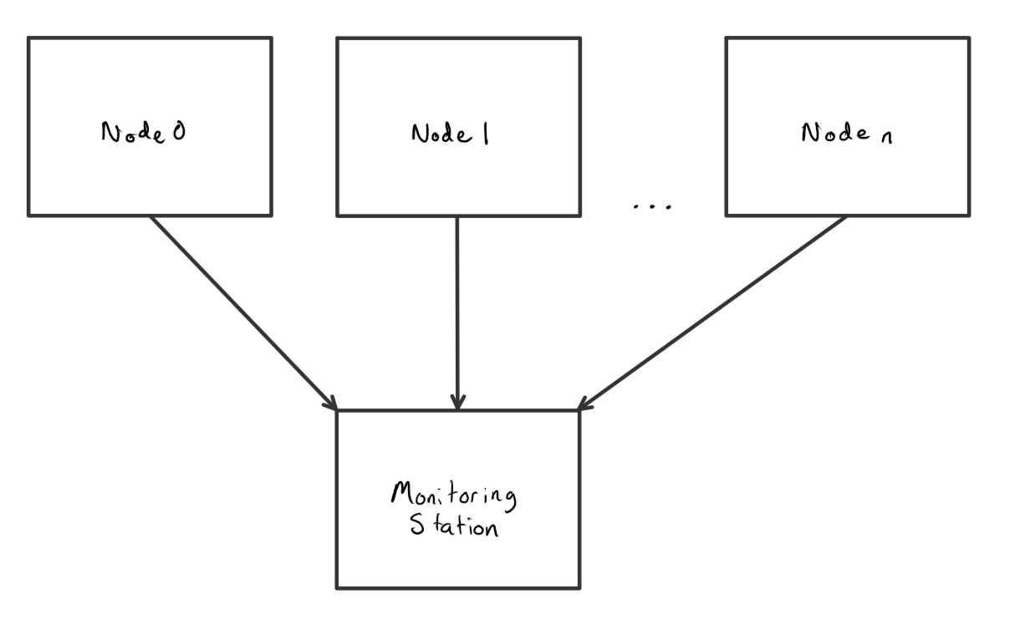

[Diagram: L1 Block Diagrams]

The team has done some initial research and estimations into power consumption versus sampling rate for each of the researched components. Below are three graphs showing this data, one for each type of sensor. The dotted red line on each graph represents the average power consumption of each sensor to obtain 1 year battery life on a single 18650 Lithium Ion battery cell.

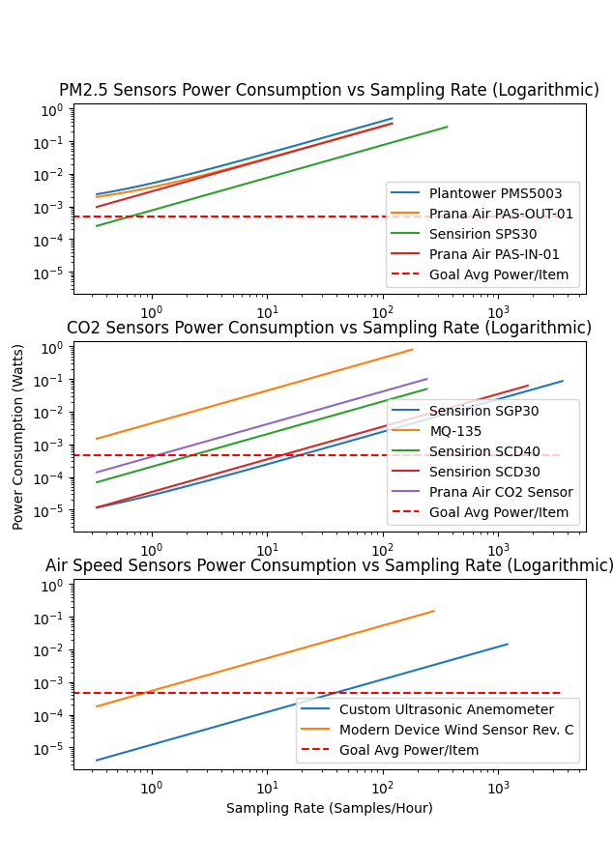

The team has also completed some estimates about whole system battery life for potentially viable sensor configurations. Information on these configurations is available in section 6.1. The only sensors included in this summary are the ones that reach low enough power consumption at any point in the above graphs. Each sensor also has a different sampling rate, which is noted in the information. The configurations are sorted by lowest average power consumption per sampling rate (i.e., lower power consumption is better and sampling more frequently is better).

From these calculations, it should be feasible to reach 1 year battery life, given enough batteries and/or low enough sampling rates.

For the duration of the project, the team is going to be performing cost-benefit analysis on several aspects of our product to determine tradeoffs in battery life as compared to project quality. The first aspect that the team is weighing that has a major impact on our project's battery life is the system’s wake up rate to pull data from our sensors. The team plans on continuing to graph and analyze this data in order to find a comfortable balance. The second important tradeoff is power consumption with respect to the quality of our sensor, where some lower quality sensors project a better energy profile, but trade off accuracy or extra features. The team will be in constant communication with Professor Burnett in order to make sure any decisions made in these respects still align with our project's goals.

### **4.6 Verification plans**

To test our project, the team is planning to run a 24-hour test run on our initial batch of 3-4 nodes, and then again later on our final batch. During these tests, which will take place during week 10 of spring quarter, the team hopes to see the data being collected, logged, and transmitted correctly. The team also will be monitoring the power consumption of each node using EnergyTrace. Testing for 24 hours should give us a good sanity check that our design should be able to run continuously for long periods of time, both from a maintenance and battery life standpoint. This test is planned to take place in the WEST Lab in FAB 60-24.

## 

## **5. Project Management Plan**

### **5.1 Timeline, with milestones**

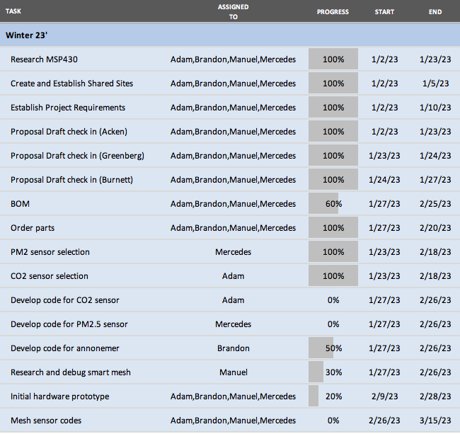

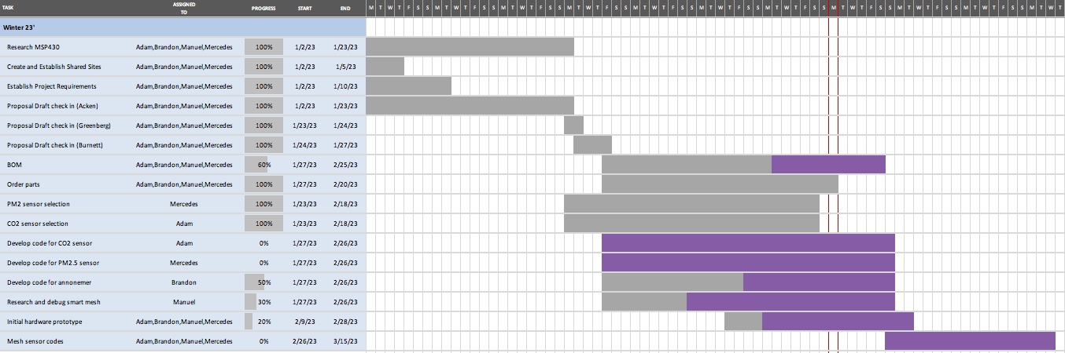

[Timelines of project - Winter]

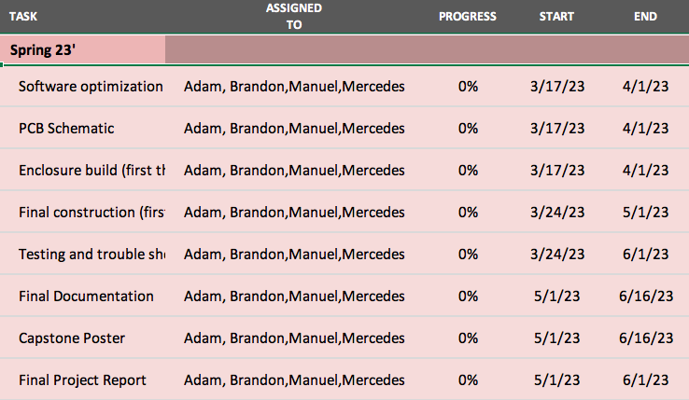

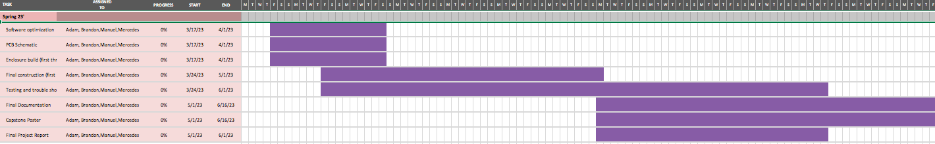

[Timeline of Project - Spring]

[Full Excel of Gantt Chart](https://github.com/brhttps://github.com/brandonhippe/412AirQualityCapstone/blob/main/Documentation/412_GanttChart.xlsxandonhippe/412AirQualityCapstone/blob/main/Documentation/412_GanttChart.xlsx)

### **5.2 Budget and Resources**

To start, the budget for this project will be $1000 with the goal of building 3-4 prototype nodes. From there, The total estimate is a cost of $300 per node, with a goal of building 10 nodes for $3000.

The team will be utilizing several spaces on the Portland State University campus including but not limited to: the EPL (Electronics Prototyping Lab) for 3D printing and project assembly, Dr Burnett's research lab for meetings and project assembly, locker space in the Engineering building for project storage, and the third floor lobby of the Fariborz Maseeh Hall building for in person planning/documentation meetings. The team will also utilize Zoom for meetings with our industry sponsor and our faculty advisor. For communication platforms, the team will be using email to communicate with Dr Burnett and Dr Acken, and group communication will be completed via text messages, Discord, and Trello to ensure completion of projects. The team will also use Github as our version control system, with a group Google Drive to share other miscellaneous items.

### **5.3 Intellectual Property Discussion**

This sensor system is intended to be open source. The design, including code, schematics, guides, and other necessary design files, will be protected under the GNU General Public License v3.0, and will be freely available on the project’s github repository.

### **5.4 Team and development process**

Team Members and Skills/Project Interests:

* Adam Dezay: Documentation, Github, Wiki, Soldering, Gantt Chart, CO2 sensor prototyping.
* [Manuel Garcia](mailto:manga2@pdx.edu): KiCad Schematic & Board Layout, Programming, Web Development, General Hardware/Software Hacking, FreeCad, SmartMesh Prototyping
* [Brandon Hippe](mailto:bhippe@pdx.edu): Coding, Sensor implementation, wireless networking implementation, 3D printing, GUI development in Python and MATLAB, Anemometer prototyping, point of contact with sponsor
* Mercedes Newton: Team captain, Weekly report leader, 3D printing, documentation, soldering, hardware implementation, power calculations, PM2.5 sensor prototyping, private consulting.

The team will be utilizing collaboration tools such as Trello, Github, Google Drive and Zoom. Our point person for communicating with our industry sponsor and advisor is Brandon Hippe, and our team leader is Mercedes Newton.

## **6. Appendices**

### **6.1 Configurations sorted by lowest power consumption / sampling rate**

1.

PM2.5 Sensors: Sensirion SPS30

Time On: 10 seconds

Time Off: 5990 seconds

Sleep Power %: 0.00%

Percent of Total Power: 30.74%

CO2 Sensors: Sensirion SGP30

Time On: 1 seconds

Time Off: 239 seconds

Sleep Power %: 0.98%

Percent of Total Power: 24.49%

Air Speed Sensors: Custom Ultrasonic Anemometer

Time On: 3 seconds

Time Off: 117 seconds

Sleep Power %: 0.00%

Percent of Total Power: 24.35%

Micro Controllers: MSP430

Time On: 157 seconds

Time Off: 5843 seconds

Sleep Power %: 3.39%

Percent of Total Power: 20.43%

Power Consumption: 1.491 mW

Cost: $81.32

Battery Life on single 18650 cell: 352.11 days

2.

PM2.5 Sensors: Sensirion SPS30

Time On: 10 seconds

Time Off: 5990 seconds

Sleep Power %: 0.00%

Percent of Total Power: 28.98%

CO2 Sensors: Sensirion SCD30

Time On: 2 seconds

Time Off: 298 seconds

Sleep Power %: 0.00%

Percent of Total Power: 26.43%

Air Speed Sensors: Custom Ultrasonic Anemometer

Time On: 3 seconds

Time Off: 117 seconds

Sleep Power %: 0.00%

Percent of Total Power: 22.95%

Micro Controllers: MSP430

Time On: 177 seconds

Time Off: 5823 seconds

Sleep Power %: 3.01%

Percent of Total Power: 21.63%

Power Consumption: 1.581 mW

Cost: $122.77

Battery Life on single 18650 cell: 331.99 days

3.

PM2.5 Sensors: Sensirion SPS30

Time On: 10 seconds

Time Off: 5990 seconds

Sleep Power %: 0.00%

Percent of Total Power: 28.49%

CO2 Sensors: Sensirion SCD40

Time On: 15 seconds

Time Off: 1785 seconds

Sleep Power %: 0.00%

Percent of Total Power: 25.64%

Air Speed Sensors: Custom Ultrasonic Anemometer

Time On: 3 seconds

Time Off: 117 seconds

Sleep Power %: 0.00%

Percent of Total Power: 22.56%

Micro Controllers: MSP430

Time On: 584 seconds

Time Off: 17416 seconds

Sleep Power %: 2.73%

Percent of Total Power: 23.32%

Power Consumption: 1.609 mW

Cost: $113.77

Battery Life on single 18650 cell: 326.30 days

4.

PM2.5 Sensors: Sensirion SPS30

Time On: 10 seconds

Time Off: 5990 seconds

Sleep Power %: 0.00%

Percent of Total Power: 32.90%

CO2 Sensors: Sensirion SGP30

Time On: 1 seconds

Time Off: 239 seconds

Sleep Power %: 0.98%

Percent of Total Power: 26.21%

Air Speed Sensors: Modern Device Wind Sensor Rev. C

Time On: 13 seconds

Time Off: 4187 seconds

Sleep Power %: 0.00%

Percent of Total Power: 33.33%

Micro Controllers: MSP430

Time On: 354 seconds

Time Off: 41646 seconds

Sleep Power %: 9.98%

Percent of Total Power: 7.56%

Power Consumption: 1.393 mW

Cost: $95.37

Battery Life on single 18650 cell: 376.88 days

5.

PM2.5 Sensors: Sensirion SPS30

Time On: 10 seconds

Time Off: 5990 seconds

Sleep Power %: 0.00%

Percent of Total Power: 28.20%

CO2 Sensors: Prana Air CO2 Sensor

Time On: 15 seconds

Time Off: 3285 seconds

Sleep Power %: 0.00%

Percent of Total Power: 27.97%

Air Speed Sensors: Custom Ultrasonic Anemometer

Time On: 3 seconds

Time Off: 117 seconds

Sleep Power %: 0.00%

Percent of Total Power: 22.34%

Micro Controllers: MSP430

Time On: 1990 seconds

Time Off: 64010 seconds

Sleep Power %: 2.94%

Percent of Total Power: 21.50%

Power Consumption: 1.625 mW

Cost: $82.82

Battery Life on single 18650 cell: 323.03 days

6.

PM2.5 Sensors: Sensirion SPS30

Time On: 10 seconds

Time Off: 5990 seconds

Sleep Power %: 0.00%

Percent of Total Power: 31.21%

CO2 Sensors: Sensirion SCD30

Time On: 2 seconds

Time Off: 298 seconds

Sleep Power %: 0.00%

Percent of Total Power: 28.47%

Air Speed Sensors: Modern Device Wind Sensor Rev. C

Time On: 13 seconds

Time Off: 4187 seconds

Sleep Power %: 0.00%

Percent of Total Power: 31.62%

Micro Controllers: MSP430

Time On: 438 seconds

Time Off: 41562 seconds

Sleep Power %: 8.20%

Percent of Total Power: 8.70%

Power Consumption: 1.468 mW

Cost: $136.82

Battery Life on single 18650 cell: 357.54 days

7.

PM2.5 Sensors: Sensirion SPS30

Time On: 10 seconds

Time Off: 5990 seconds

Sleep Power %: 0.00%

Percent of Total Power: 31.11%

CO2 Sensors: Sensirion SCD40

Time On: 15 seconds

Time Off: 1785 seconds

Sleep Power %: 0.00%

Percent of Total Power: 28.00%

Air Speed Sensors: Modern Device Wind Sensor Rev. C

Time On: 13 seconds

Time Off: 4187 seconds

Sleep Power %: 0.00%

Percent of Total Power: 31.51%

Micro Controllers: MSP430

Time On: 1430 seconds

Time Off: 124570 seconds

Sleep Power %: 7.58%

Percent of Total Power: 9.37%

Power Consumption: 1.473 mW

Cost: $127.82

Battery Life on single 18650 cell: 356.36 days

8.

PM2.5 Sensors: Sensirion SPS30

Time On: 10 seconds

Time Off: 5990 seconds

Sleep Power %: 0.00%

Percent of Total Power: 30.86%

CO2 Sensors: Prana Air CO2 Sensor

Time On: 15 seconds

Time Off: 3285 seconds

Sleep Power %: 0.00%

Percent of Total Power: 30.61%

Air Speed Sensors: Modern Device Wind Sensor Rev. C

Time On: 13 seconds

Time Off: 4187 seconds

Sleep Power %: 0.00%

Percent of Total Power: 31.26%

Micro Controllers: MSP430

Time On: 4000 seconds

Time Off: 458000 seconds

Sleep Power %: 9.73%

Percent of Total Power: 7.26%

Power Consumption: 1.485 mW

Cost: $96.87

Battery Life on single 18650 cell: 353.53 days

### **6.2 CO2 Sensor Comparisons**

|  | [SGP 30](https://www.adafruit.com/product/3709) | [SCD 30](https://www.adafruit.com/product/4867) |
| --- | --- | --- |
| Type | E CO2 | CO2 |
| Additional sensors | VOC | * Temp * Humidity |
| Range | 400-60k PPM | 0-40k PPM |
| Accuracy | ±15% | ±30PPM +3% |
| Power Consumption (On) | ~86 mW | ~63 mW |
| Power Consumption (Off) | ~3.6 μW | ~20 mW (likely requires full shutoff) |
| Price ($) | 17.50 | 58.95 |
| Relative Size | Size of quarter | Double size |

Average outdoor PPM is 414 PPM

Cities have PPM between 600-900

OSHA permits up to 5K PPM per 8 hour exposure

40K PPM is where it gets to the deadly range

ANSI recommends below 700 PPM outdoor and 1200 PPM Indoor

Sources:

[USDA](https://www.fsis.usda.gov/sites/default/files/media_file/2020-08/Carbon-Dioxide.pdf)

[SGP30 Overview/datasheet/tutorial...etc](https://learn.adafruit.com/adafruit-sgp30-gas-tvoc-eco2-mox-sensor/overview)

[SCD 30 Overview/datasheet/tutorial...etc](https://learn.adafruit.com/adafruit-scd30)

### **6.3 PM2.5 Sensor Comparisons**

|  | [PMS5003](https://shop.pimoroni.com/products/pms5003-particulate-matter-sensor-with-cable?variant=29075640352851) | [PAS-OUT-01](https://www.pranaair.com/us/air-quality-sensor/outdoor-pm-sensor/) | [PAS-IN-01](https://www.pranaair.com/air-quality-sensor/indoor-pm-sensor/) | [SPS30](https://sensirion.com/products/catalog/SPS30/) |
| --- | --- | --- | --- | --- |
| Range (concentration) | 0-500 ug/m3 | 0-31000 ug/m3 | 0-1500 ug/m3 | 0-1000 ug/m3 |
| Accuracy | ±10% or ±10 ug/m3, whichever is greater | ±10% or ±10 ug/m3, whichever is greater | ±1ug/m3, | ±10% or ±10 ug/m3, whichever is greater |
| Power Consumption (On) | ~500 mW | ~350 mW | ~350mW | ~275 mW |
| Power Consumption (Off) | ~1 mW (likely requires full shutoff) | 0 mW (no sleep mode, full shut off) | 0 mW (no sleep mode, full shut off) | ~0.2 mW |
| Price ($) | 39.95 | Request Quote,  student discount | Request Quote, student discount | 49.53 |
| Notes | 30 seconds before accurate data, needs calibration every 30 days | 30 seconds before accurate data | 15 seconds before accurate data, | 10 seconds before accurate data |

### 

### **6.4 Airflow Sensor Comparisons**

|  | [Custom Ultrasonic Anemometer](https://hackaday.com/2013/08/21/ultrasonic-anemometer-for-an-absurdly-accurate-weather-station/) | [Wind Sensor Rev. C](https://moderndevice.com/products/wind-sensor) |
| --- | --- | --- |
| Type | Ultrasonic | Hotwire |
| Range | Unknown and depends on size (will build and test) | 0-60 MPH |
| Accuracy | Unknown and depends on size (will build and test) | Can detect “small puff of air at a distance of 18-24 inches” |
| Power Consumption (On) | ~14.52 mW | ~150 mW |
| Power Consumption (Off) | 0 mW (no sleep mode, full shut off) |  |
| Price ($) | 7.90 | 21.95 |
| Relative Size | ~25-36 cm apart | .68″ × 1.590″ × .25″ |
| Notes | Requires custom design | 10 second warm-up time |

1. https://www.co2meter.com/blogs/news/co2-levels-at-home
2. https://apps.who.int/iris/bitstream/handle/10665/345329/9789240034228-eng.pdf
3. https://www.davisinstruments.com/pages/airlink
4. https://www.airgradient.com/